Leonardo’s Chronicles

Product Design Specification

Version 1.0

November 30th 2015

VERSION HISTORY

The project development so far is the result of the first of 3 sprints coming to an end. Testing of version 1.0 is currently under way after which, will follow kick off of sprint number 2, marking the beginning of version 1.1.

Ultimately however, as this is project is based on my own story, I will be providing each version sign off. A version will be signed off once the requirements for that version are met. For a breakdown of timelines and the requirements of each iteration, please consult the Gantt chart provided in the Project Proposal documentation.

|  |  |  |  |  |  |
| --- | --- | --- | --- | --- | --- |
| **Version #** | **Implemented**  **By** | **Revision**  **Date** | **Approved**  **By** | **Approval**  **Date** | **Reason** |
| 1.0 | Giancarlo Antonio Luongo | 30/11/2015 | Giancarlo Antonio Luongo | 30/11/2015 | Phase 1 completed |
|  |  |  |  |  |  |
|  |  |  |  |  |  |

**UP Template Version:** 30/11/15

TABLE OF CONTENTS

**1** **Introduction**

1.1 Purpose of The Product Design Specification Document

**2** **General Overview and Design Guidelines/Approach**

2.1 Assumptions / Constraints / Standards

**3** **Architecture Design**

3.1 Logical View

3.2 Hardware Architecture

3.3 Software Architecture

3.4 Security Architecture

3.5 Communication Architecture

3.6 Performance

**4** **System Design**

4.1 Use-Cases

4.2 Database Design

4.3 Application Program Interfaces

4.4 User Interface Design

# Introduction

## Purpose of The Product Design Specification Document

The purpose of this document is to ensure that production of the application “Leonardo’s Chronicles”, closely reflects my expectations and conveys the message in the correct tones. The idea comes from a concept I had some time ago about creating a cartoon series. I realize now that the best medium to tell an adventure story, is to allow the consumer to “live” that story and play through it rather than just watching it.

The challenge in this project is to keep a balance of play time, storytelling and action all balanced in order for this to be an enjoyable experience. Close attention will be and has been paid so far too small details and creating a persona for each character that the player encounters throughout his/her play through.

All these expectations need to be the standard throughout development.

# General Overview and Design Guidelines/Approach

This section describes the principles and strategies to be used as guidelines when designing and implementing the system.

## Standards

The application design will follow medieval/fantasy design throughout. This is a key design standard that needs to be adhered to in order to keep the application’s content consistent.

Below is a list of acceptable design standards for a variety of different circumstances. These guidelines need to be strictly followed where possible.

Note that these are screenshots from the work-in-progress and they are guidelines:

**Outdoors**

* Towns (snow)

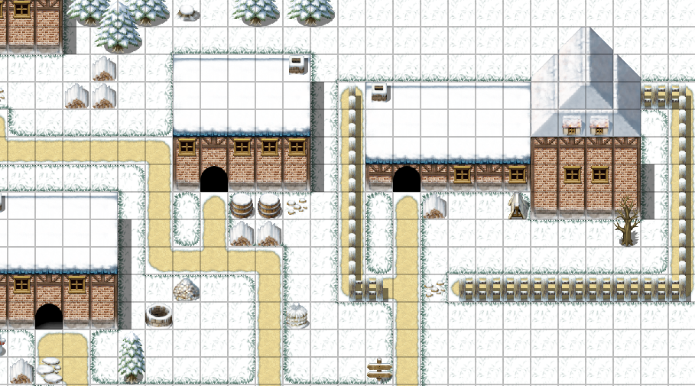

* Towns (sunny)

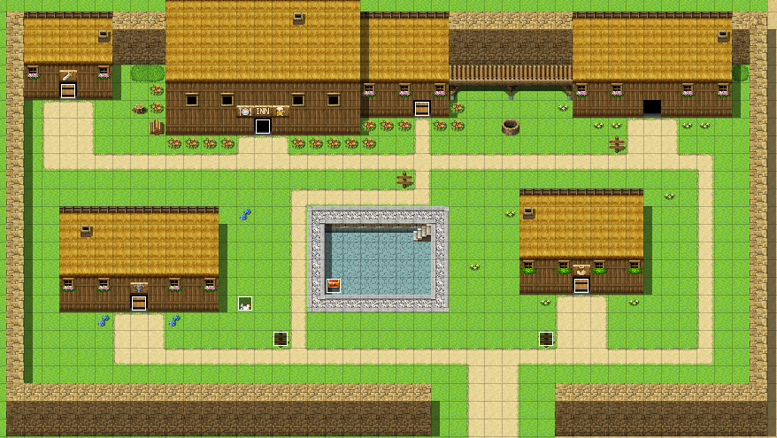

* Castles

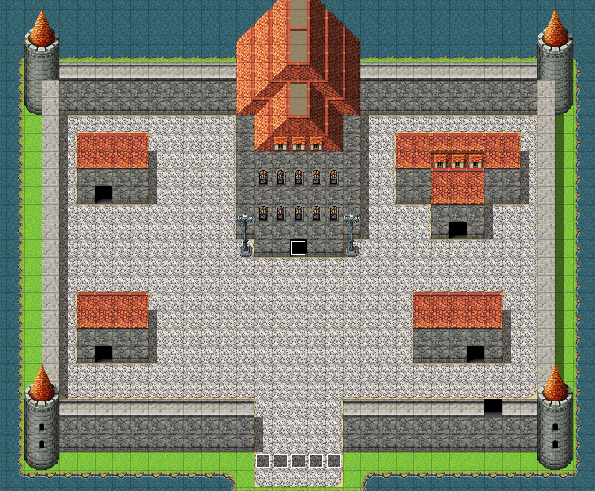

* World Map

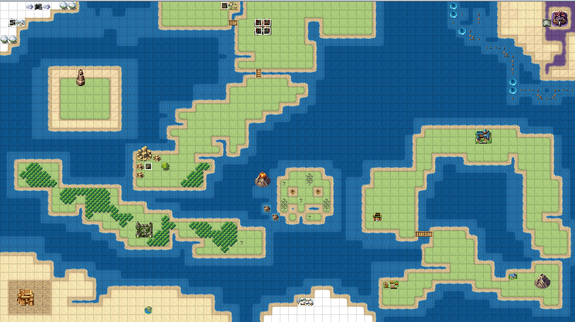

**Indoors**

* Towns (sunny/snow)
* Weapons Shop:

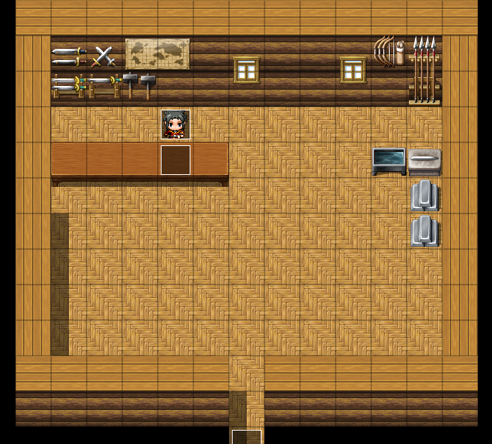

* Items Shop:

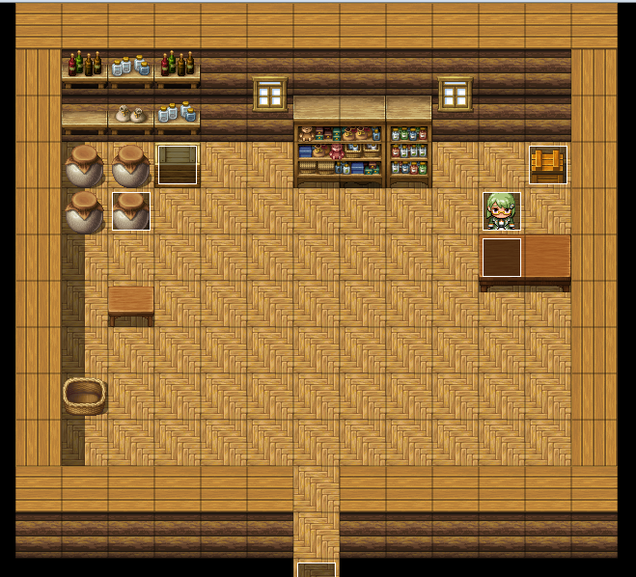

* Armours Shop:

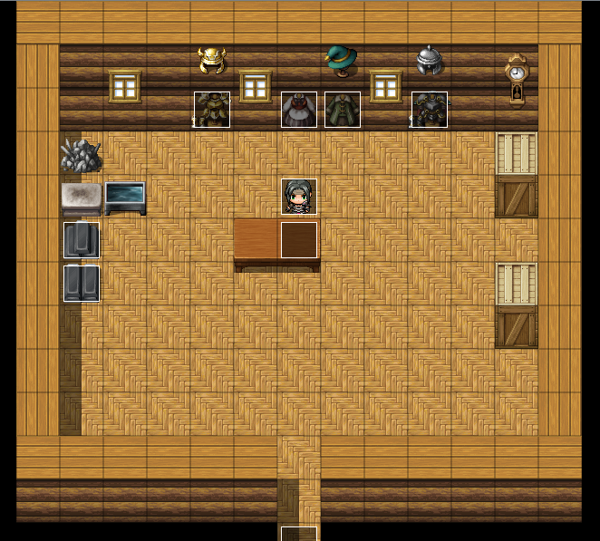

* Inn:

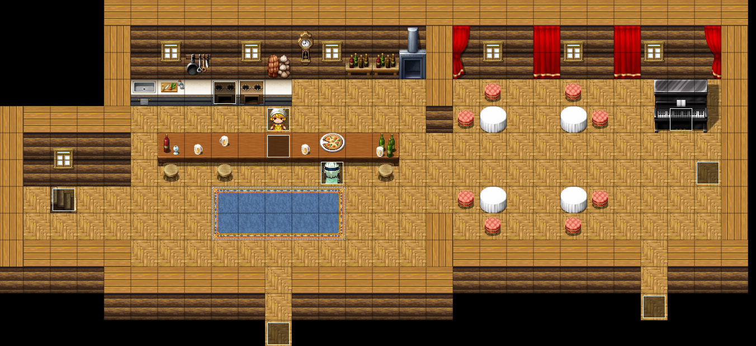

* Inn Bedrooms:

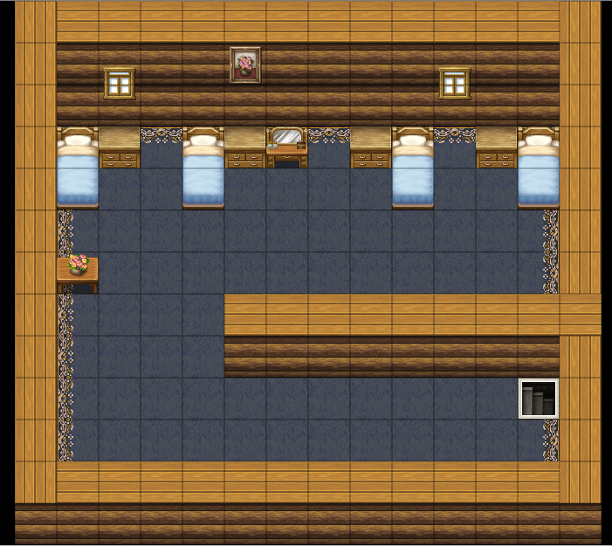

* Castles

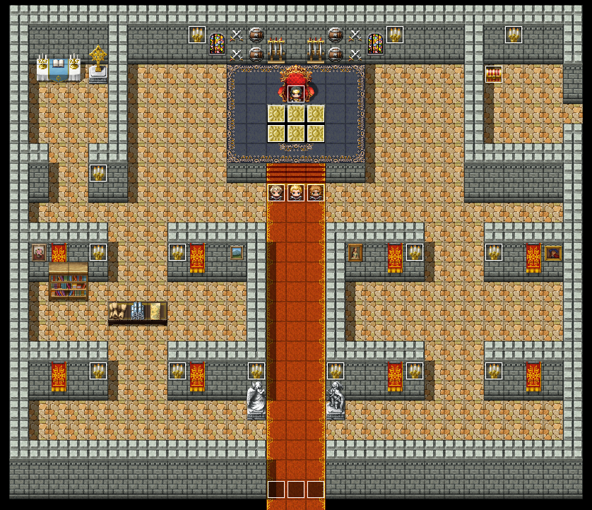

And finally, Dungeons:

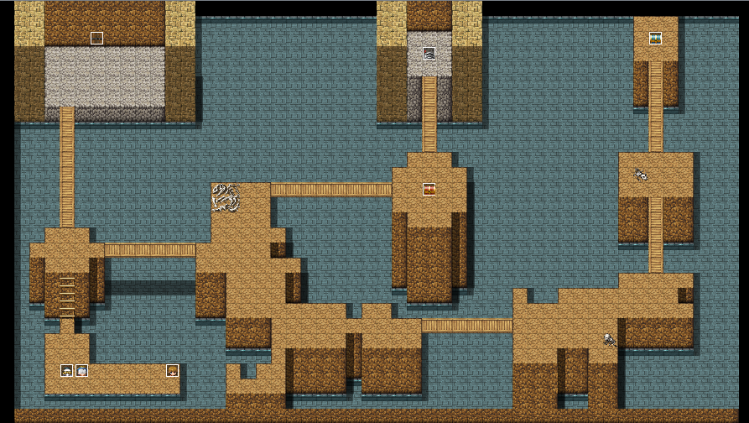

As well as the in-game architectural and environmental design restrictions, developers will have to abide by character design restrictions and how interactions between characters (both player and non-playable characters) occur.

**Character**

**Interactions**

All interactions where a character speaks to another will have to include a text box and a portrait of the character that is currently speaking (example 1). However, this can sometimes be overridden where the character who is currently talking, is the only character available/visible in the scene. Should this occur, a character portrait is only mandatory for the first block of text being displayed in the text box which in turn, remains a mandatory requirement (example 2).

**Example 1: Leonardo, aka “X” interacts with Igor aka “Y”**

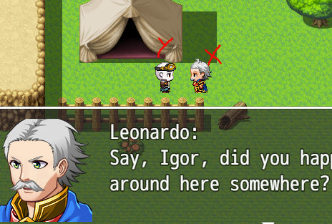

**Example 2: One character speaks in the scene, her portrait was only displayed the first time she began talking**

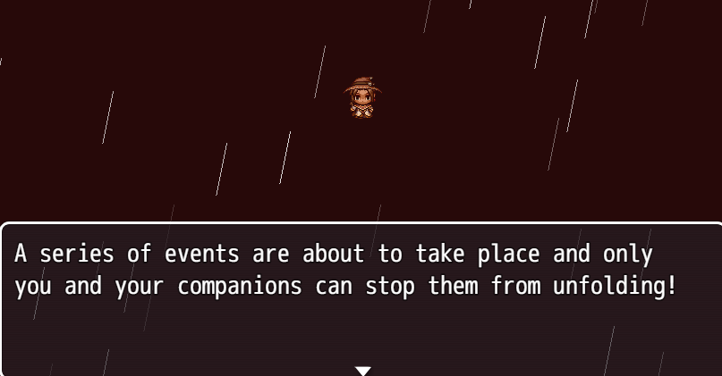

**Tutorials**

Tutorials will be displayed to the player via a text box. This type of text box will not have a portrait and will be of a different opacity in order to distinguish it from a standard textbox. Developers working on this project will have to keep this consistent throughout development as to not create confusion for the players (example 3):

**Example 3**

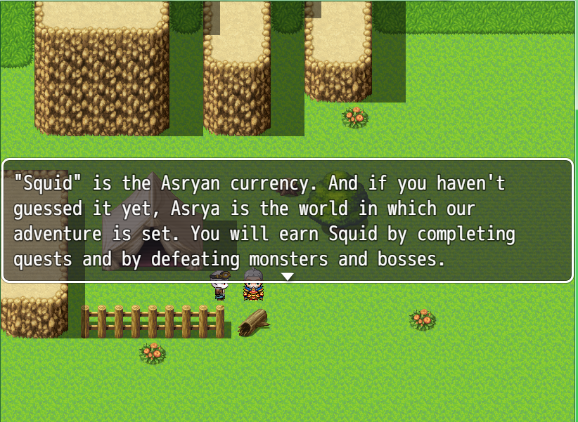

# Architecture Design

The application is being developed using a game engine called RPG Maker MV.

RPG Maker MV is a powerful engine which itself is built using JavaScript and a number of JavaScript libraries (unavailable online but made available to license holders).

Once development has completed, I will be compiling the application using the Android SDK allowing deployment of the Android market and a vast variety of compatible platforms.

## Logical View

*[Insert any related logical views or provide a reference to where they are stored.]*

## Software Architecture

The following is a representation of the system architecture. The application will be hosted locally on a device running the Android OS. The application will have a back end DB that will store all the resources and game information. The application will be hosted locally

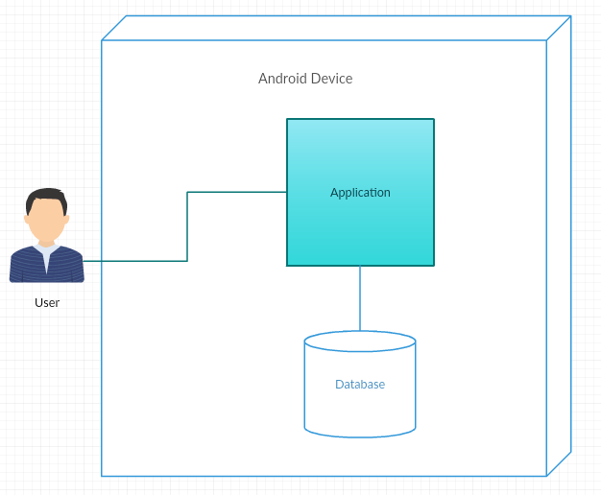

# System Design

## Use-Cases

**Application Start**

**Scope**

The scope of this use case is to describe how the player can launch the application.

**Use Case Diagram**

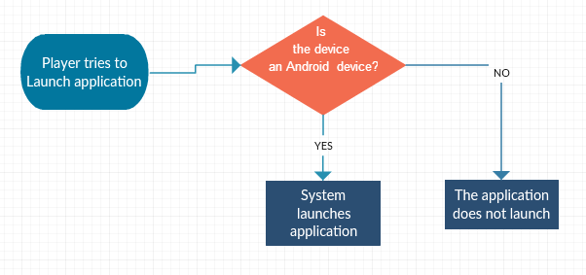

**New Game**

**Scope**

The scope of this use case is to describe how the player can start playing the game, once the system has booted up.

**Use Case Diagram**

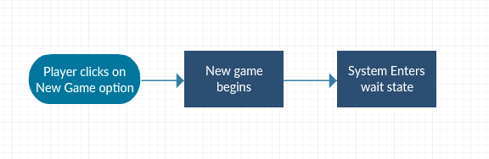

**Move Player Avatar**

**Use Case**

**Scope**

The scope of this use case is to allow a player to navigate through the virtual world and therefore play the game.

**Use Case Diagram**

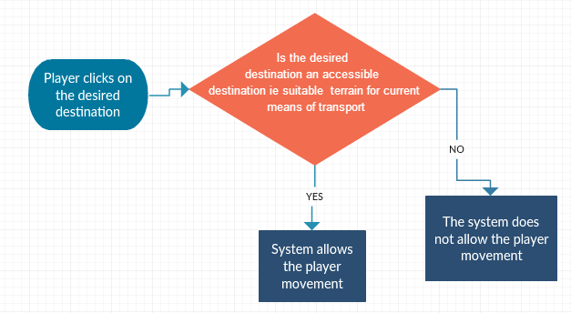

**Load Game**

**Scope**

The scope of this use case is to describe how the player can load a previously saved game.

**Use Case Diagram**

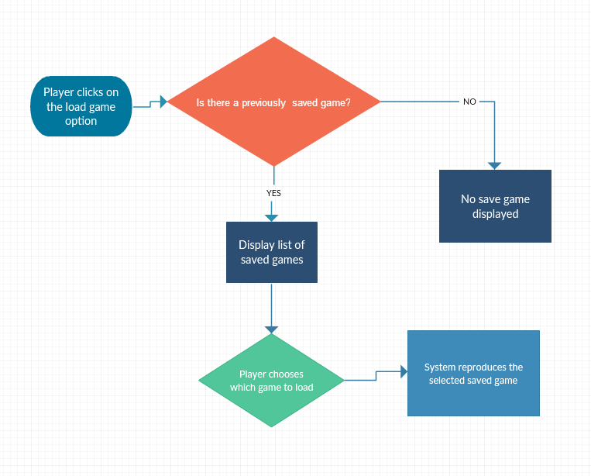

**Battle**

**Scope**

The scope of this use case is to describe how the player can load a previously saved game.

**Use Case Diagram**

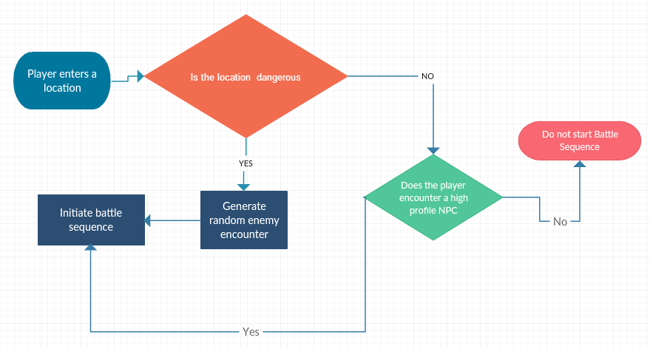

**Buy & Sell**

**Scope**

To be able to either buy and therefore procure new equipment OR sell redundant equipment.

**Use Case Diagram**

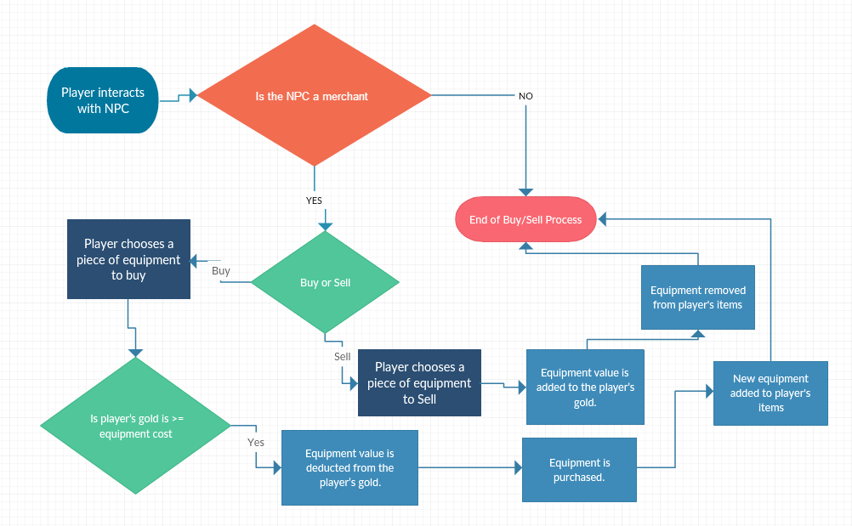

**Quests**

**Scope**

In order to set an end condition to the game, the player will face a set of specific quests.

**Use Case Diagram**

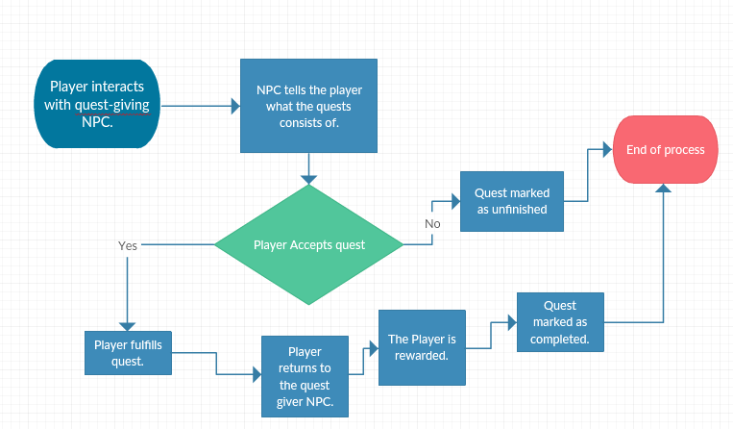

## Database Design

*This is not yet available and will only become available when the application is ported to Android.*

## Application Program Interfaces

*[Insert any application program interface documents or provide a reference to where they are stored.]*

## User Interface Design

**Application Start/Load Game/New Game**

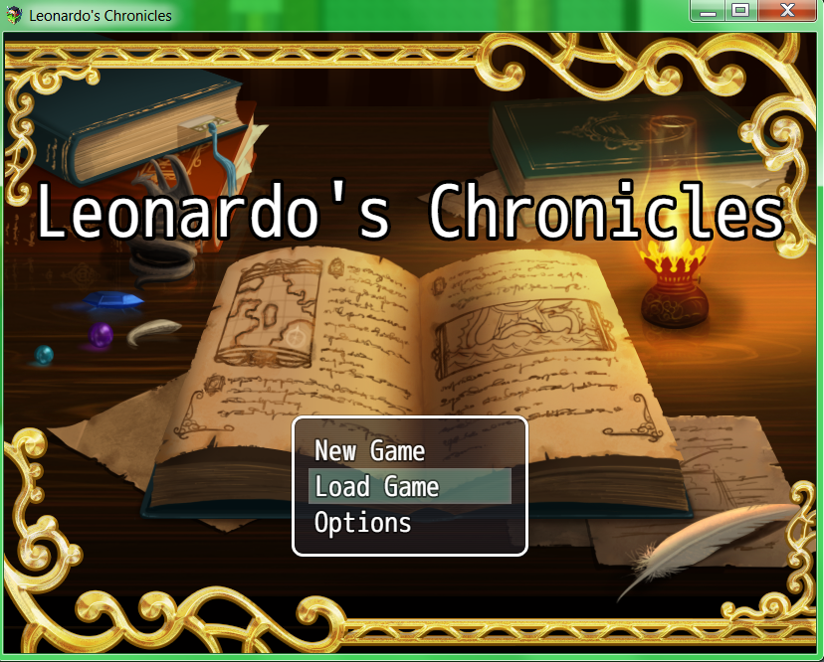

**Move Player Avatar**

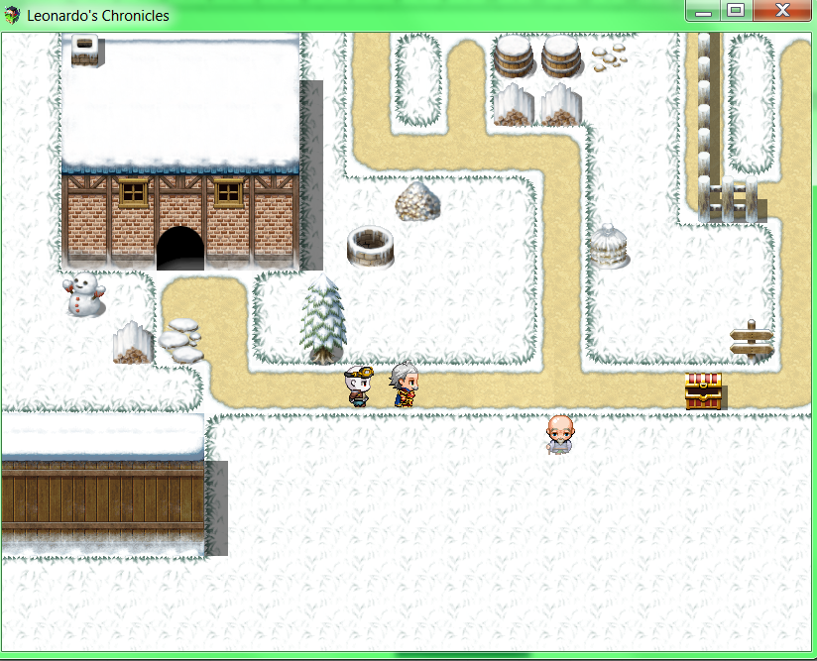

**Load Game**

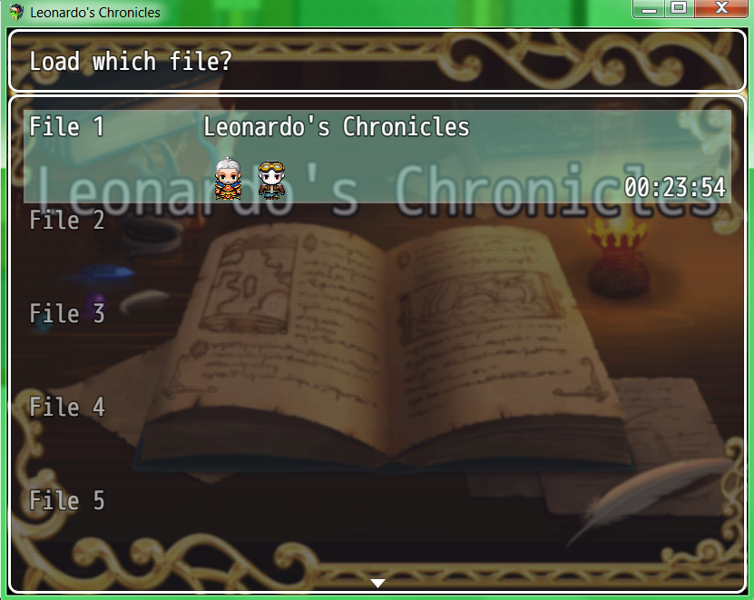

**Battle**

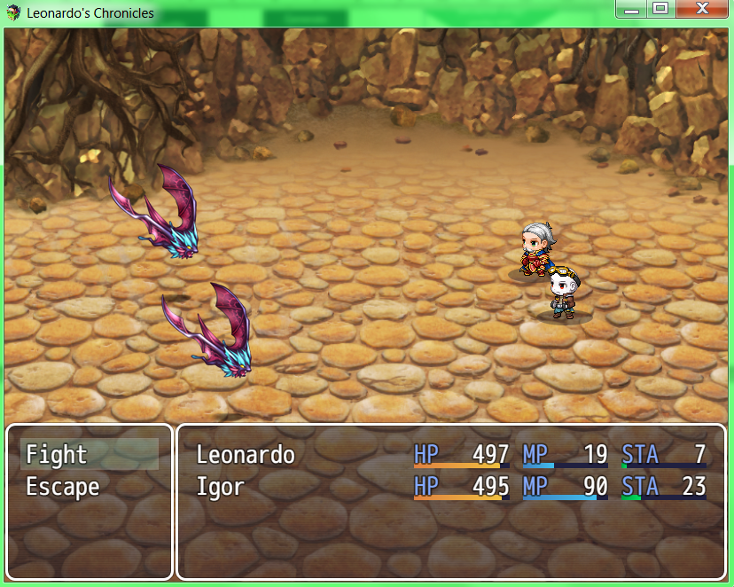

**Buy & Sell**

